POWER BI DESKTOP SCREENSHOTS

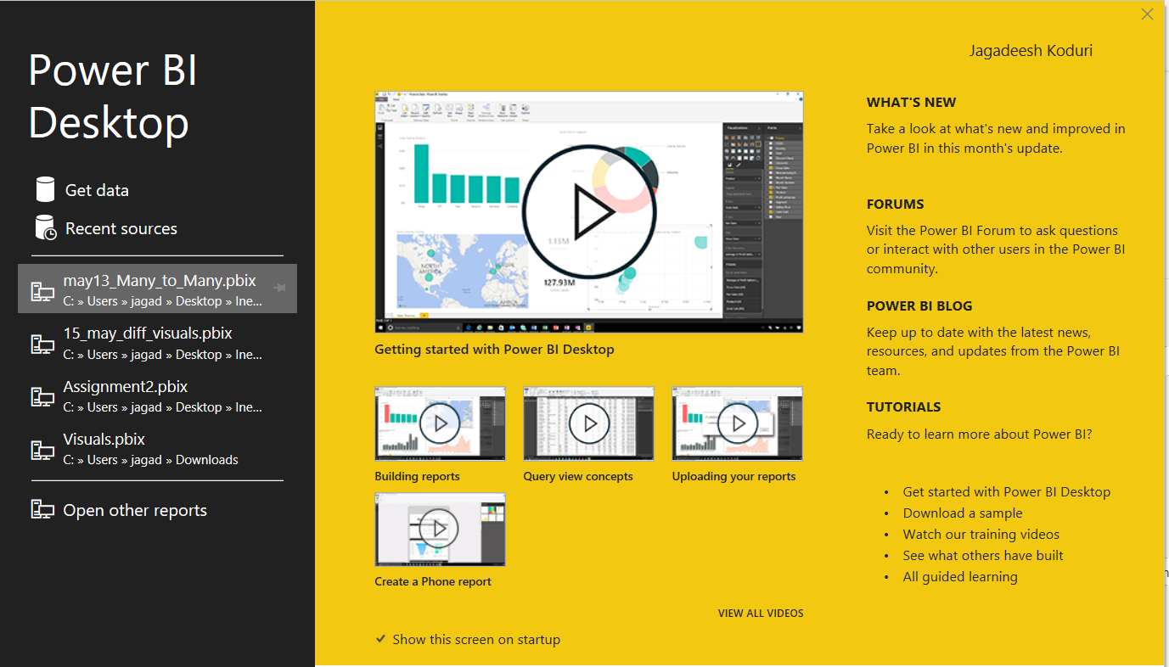

# 1.REPORT VIEW

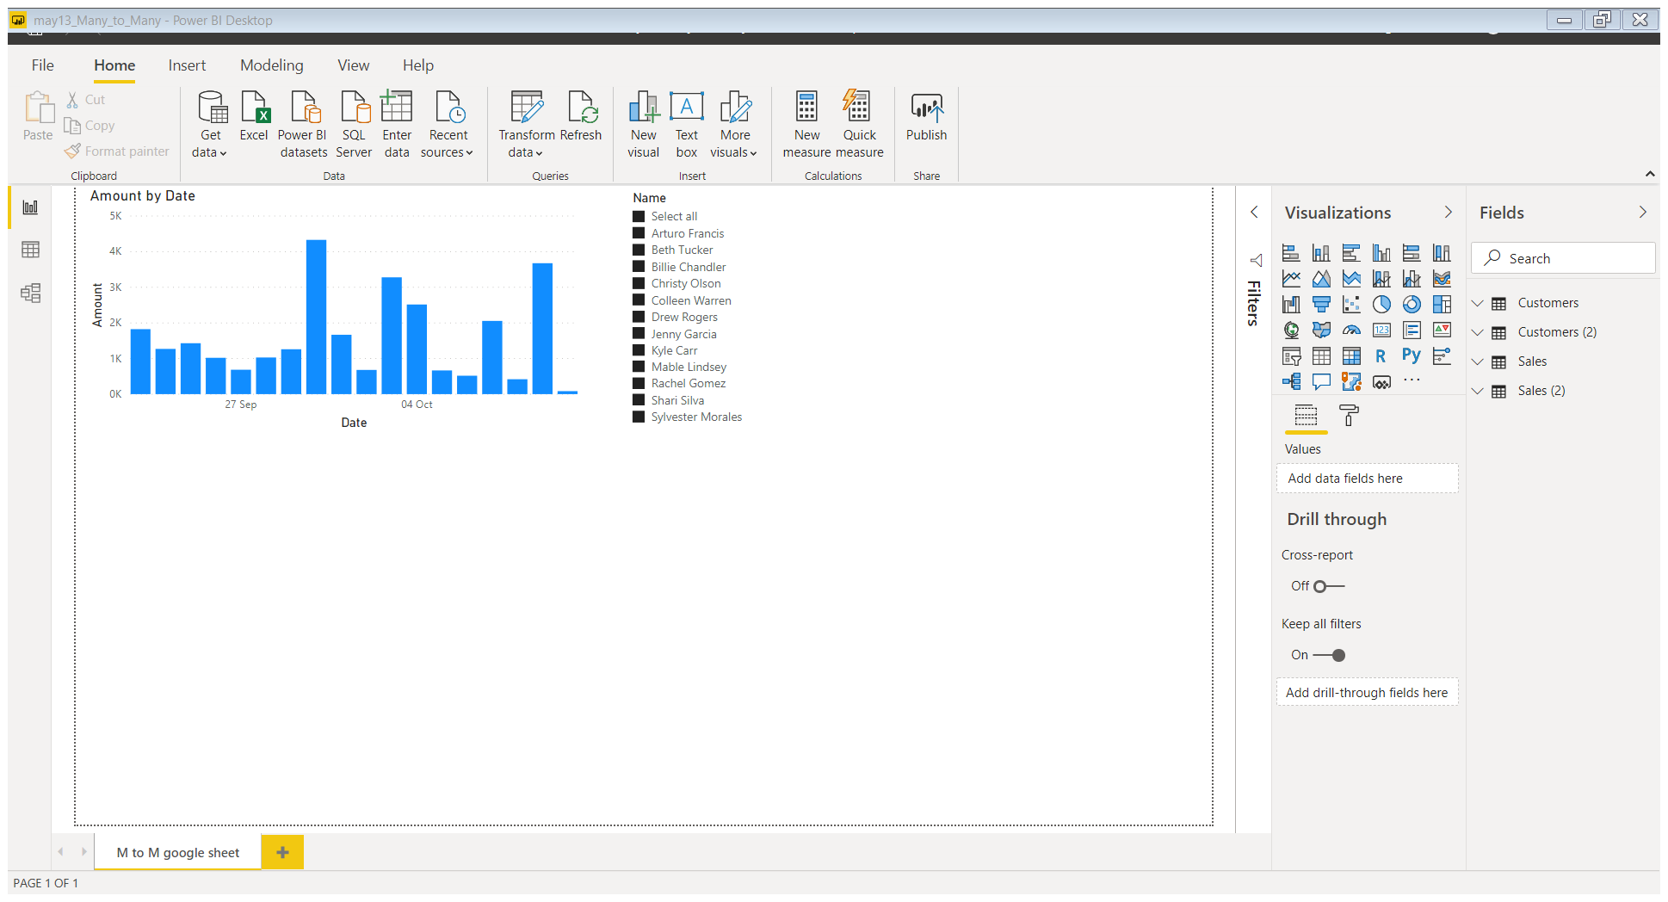

# 2. DATA VIEW

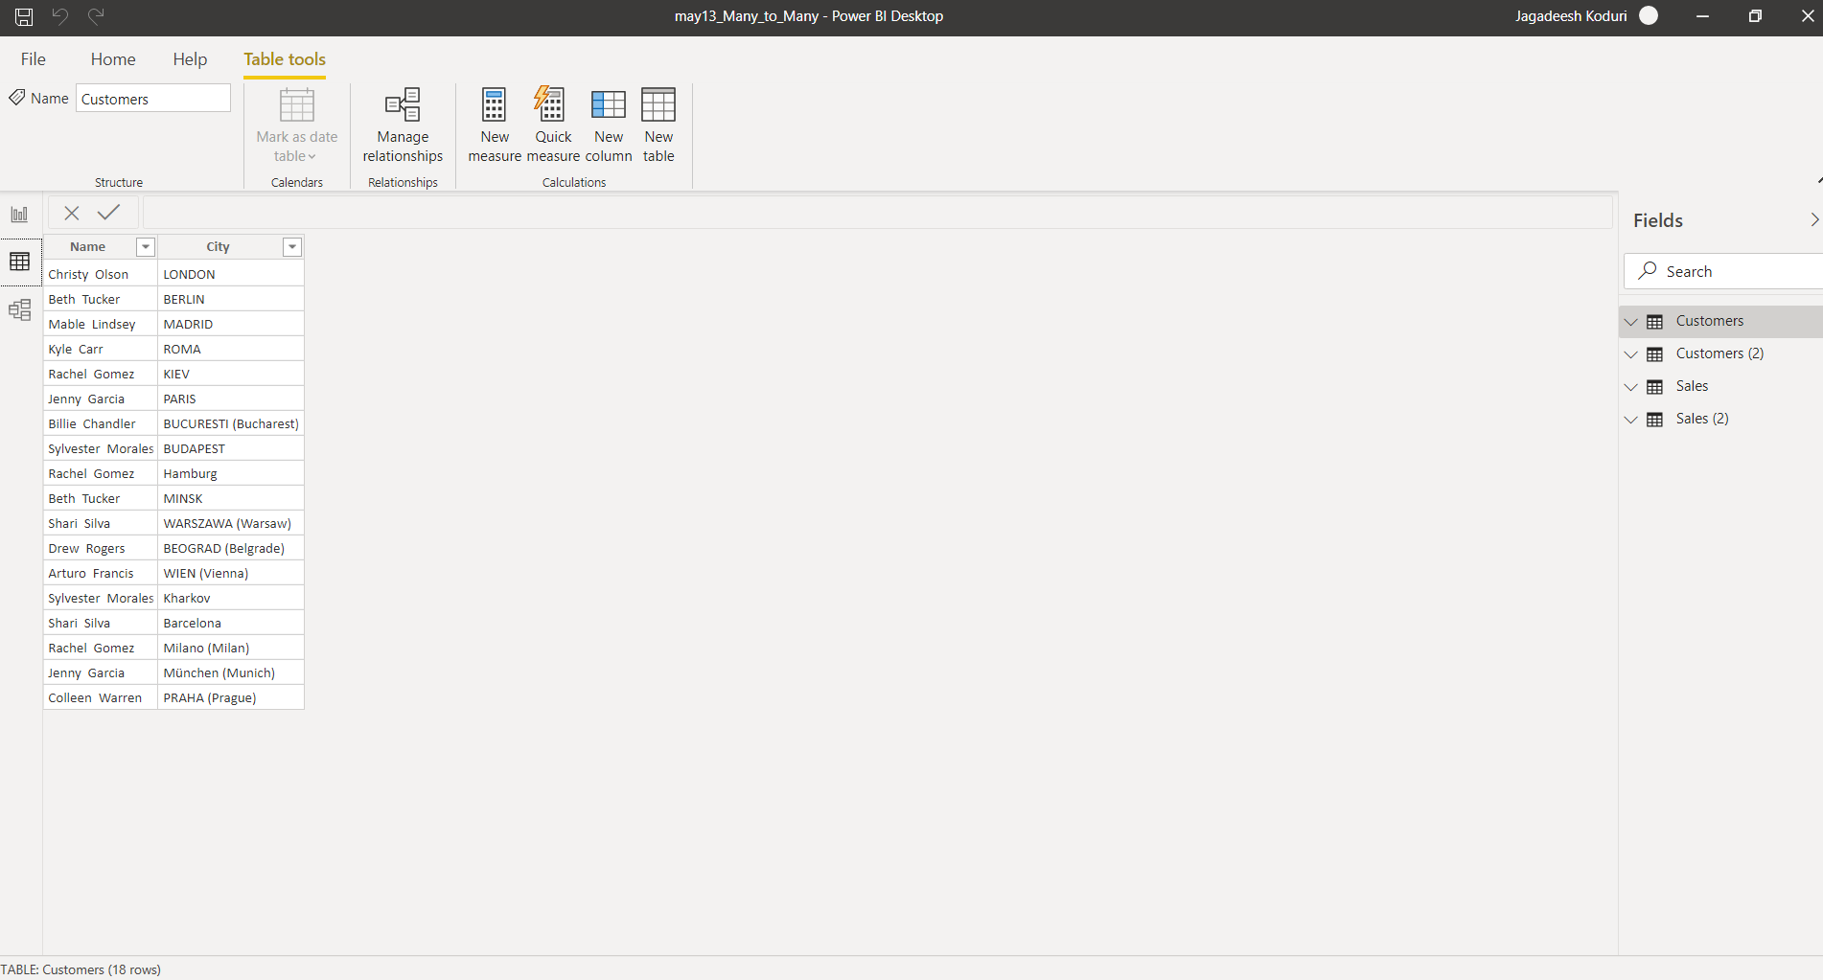

# 3. MODEL VIEW

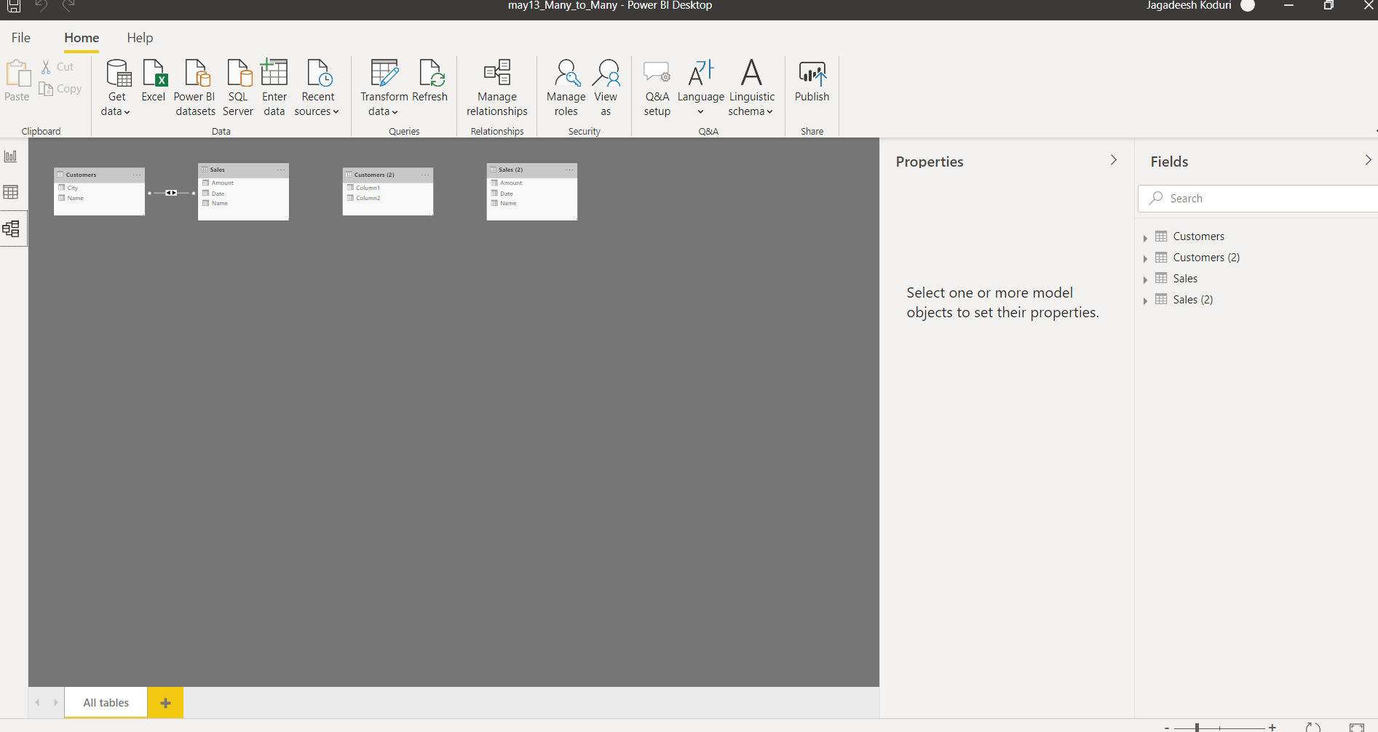

# 4. POWER QUERY EDITOR

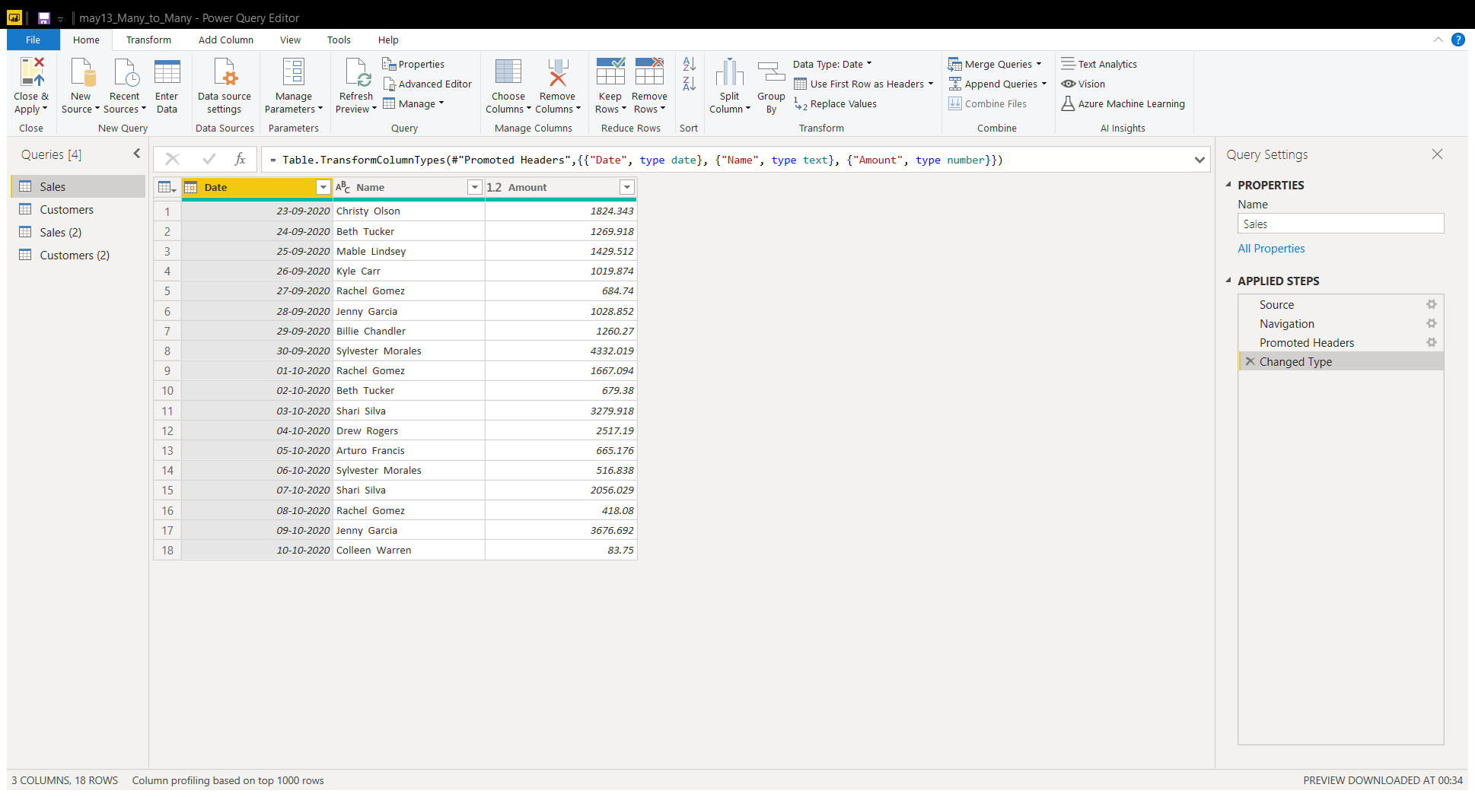

# 5. ADVANCED EDITOR

